Technical guidelines for group data migration from Hutch IT to CSCS services
Data migration workflow

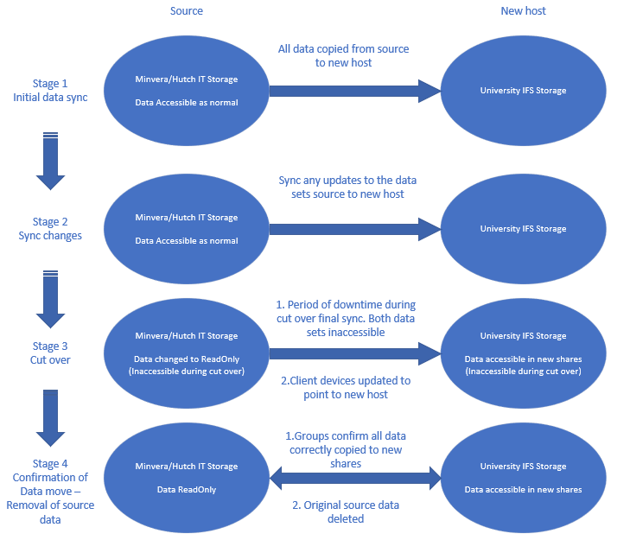
Group drive permissions
Due to cross-domain data migration, it is not possible to retain permissions when disabled inheritance has been applied. As such the following will apply:
There will be only one security group per groupdrive per PI group to be migrated.
In limited cases of shared groupdrives where users of different groups will need to collaborate with each other these will be treated as different groupdrives (nested shares) where both security groups from each group will be added
Users will need to remove any confidential data and/or PID as data migrating across will be accessible by the entire group (Please refer to the Data Storage and Management document for suggested locations to store this data to comply with University guidelines).

IFS drive sizing and data cleansing
The maximum size for any IFS share is 100TB (this includes snapshot reserve). As a result of this groups with large datasets will therefore need to categorise their data into chunks of max 80TB (This is to provide room for data growth and mitigate snapshot overflow).
CSCS request groups complete data cleansing and organisation to assist with the migration and complete the following:
- Groups to provide source path of their data (e.g \\minerva\centre\GroupName etc)
- Groups with large data sets (larger than 80tb total) need to follow below structure for data migrations.
  - Group Name
    - Folder_x (max 80tb)
    - Folder_y (max 80tb)
    - Folder_z (max 80tb)
SMB / NFS Shares and drive structuring
IFS does not support mixed mode protocol. All shares must be either CIFS (SMB) or NFS shares. CSCS recommends using SMB(CIFS) shares as these are compatible with both Windows, Linux and MAC and can be mounted via fstab (on Mac and Linux) in the same way as NFS.
SMB shares are compatible with DFS namespace (\\medlan.cam.ac.uk\) we will use to centralise Groups shares so users can access everything from one path. Any NFS shares created would need individually mounting.

Example structure:
DFS structure of a nested configuration will be as below.
- DFS Namespace \\medlan.cam.ac.uk\ed
  - GroupName_x
    - Folder_a (IFS Share)
    - Folder_b (IFS Share)
    - Folder_g (IFS nested share)
  - GroupName_y
    - Folder_c (IFS Share)
    - Folder_d (IFS share
    - Folder_g (IFS nested share)
  - GroupName_z

